Game of Stacks

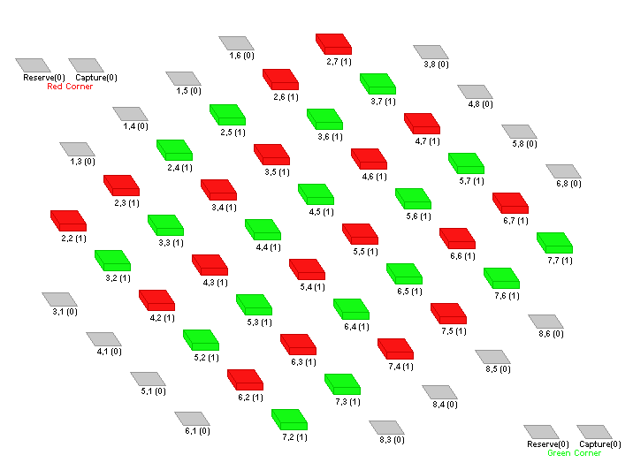
The game of stacks is a multiplayer (2 to 4 players) board game. In all there are 36 coins, 18 of red colour and 18 green. The initial placement of the coins on the board is as shown in Figure 1 below. (Please note that the board in Figure 1 is placed in a diagonal fashion, the cells on the board have been indexed for easier identification of rows and columns) In the starting position 16 cells are left vacant (indicated by the Gray boxes in Figure 1). The cells in the corner of the board are removed. Additionally there are two special cells at the top and bottom corners of the board, diagonally opposite to each other, marked as ‘Reserve’ and ‘Capture’. One set of these special cells is also labelled as ‘Red Corner’ and the other set as ‘Green Corner’. As the labels indicate each corner belongs to the player that owns that colour of coin. In other words, the Red Corner is owned by the player playing with red coins and the Green Corner by the player playing with green coins. All the other rules in the rest of this document are for the two player version of the game.

Figure 1: Initial board layout at the start of a game

There are two objectives of this game which are as follows.
- To dominate the entire game board so that the opponent cannot make a move
- To capture 9 of the opponent’s coins
The first player to achieve either one of the above objectives wins the game.

The basic move in this game is to pile up the coins onto other coins to form stacks. A player, whose colour coin is on top of a stack, controls the stack that is the player dominates the stack. Only that player who dominates the stack can move coins from that stack. If a player’s colour coin is on top of all the stacks on the board and the opponent player cannot move then the player wins the game.
In Figure 2 the stacks at (3, 5) & (5, 4) are dominated by the player playing with green coins and the stack at (3, 3) is dominated by the player playing with red coins.
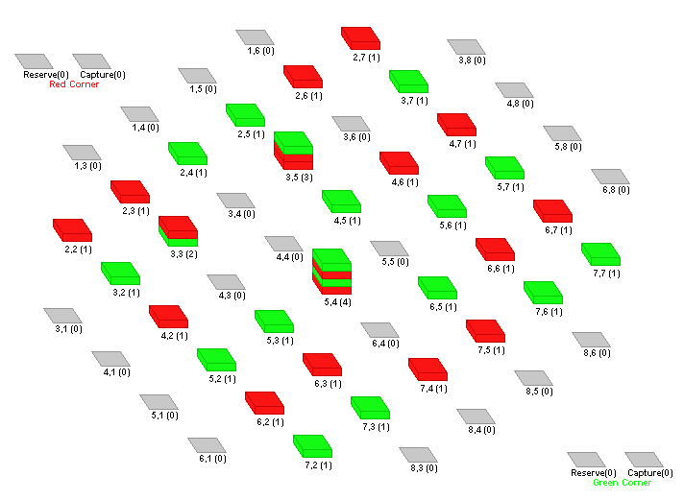

Figure 2: Board with stacks

Each player takes turns alternately to move coins. In each turn a player can play only a single move. The moves are of two basic types which are as follows.
Single Move: A player in its turn can move a single coin of his colour one adjacent cell vertically or horizontally but not diagonally. The coin he picks can be from a stack that has only a single coin or is the topmost coin on a stack that has multiple coins. Playing four such moves on the board shown in Figure 2 by picking the coins from the stacks in the cells (4, 2), (3,3), (5,6) and (5, 4) yields the board shown in Figure 3. All coins have been moved one adjacent cell either vertically or horizontally to the stacks at (5, 2), (4, 3), (5, 5) and (5, 3) respectively.

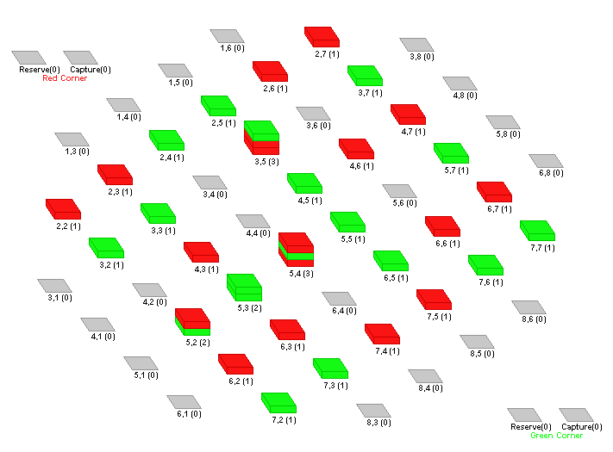

Figure 3: Board after the single moves played on the board in Figure 2.
Multiple Move: A player can also move a stack of coins or parts of a stack of coins. To make a multiple move a player can only move a stack that has one of the player’s colour coins topping it (The player must dominate the stack). The player can only make a multiple move vertically or horizontally on the game board never diagonally. The player can also jump over other stacks of coins while moving and not affect them. The most important rule to remember when making a multiple move is the number of coins the player picks up in a pile to move determines the number of cells the player has to move on the game board. The order of the coins in the stack or part of the stack that is picked by the player to move remains unchanged after the move is completed. To understand this better consider the following moves on the board in Figure 3.
- Both the coins in the stack at (5, 3) is moved 2 places to (3, 3) by the player playing with green coins
- The top two coins in the stack at (5, 4) is moved 2 places to (5, 2) by the player playing with red coins
- All the coins (3) in the stack at (3, 5) is moved 3 places to (6, 5) by the player playing with green coins
An additional move of the coin at (7, 4) to (7, 5) has also been played by the player playing with red coins so that the moves alternate between the two players. Figure 4 shows the board after these moves have been played.

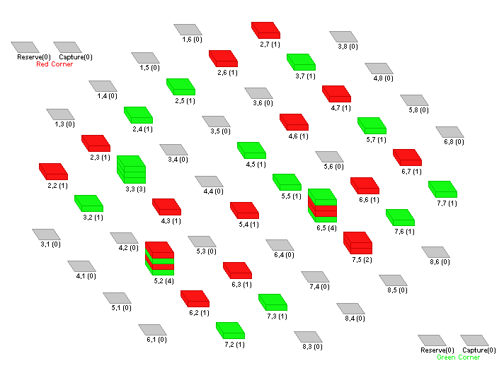

Figure 4: Board after the multiple moves played on the board in Figure 3.
When making either a single move or a multiple move a player may create a stack that has more than 5 coins. If a player does so, then any coins in excess of 5 is removed from the bottom of the stack as no stack on the board can have more than 5 coins. The excess coins are removed immediately after the move is played by a player and before the next move is played by the other player. These excess coins are either captured, that is removed from the board permanently, or kept in reserve to be played at a later time depending upon who the coins belong to and what colour they are.
If a player forms a stack of more than 5 coins on a move, any excess coins of the player’s colour become reserve coins for the player and any excess coins of the opponent’s colour are captured pieces and are permanently out of the board.
Consider the board in Figure 5. The following moves are played on this board.
- The player playing with red coins moves all the coins (4) in the stack at (5, 2) 4 positions to the stack at (5, 6). This creates a stack of eight coins at (5, 6). This means that 3 coins from the bottom of this new stack at (5, 6) would have to be removed to reduce the stack to 5 coins. Doing so removes 2 red coins and one green coin. Since this was the move of the player with red coins, the 2 red coins will become reserve coins in the Red Corner and the one green coin will be captured in the Red Corner and will be permanently out of the board.
- The player playing with green coins moves the top two coins in the stack at (4, 5) 2 places to the stack at (6, 5). This creates a stack of seven coins at (6, 5). This means that 2 coins from the bottom of this new stack at (6, 5) would have to be removed to reduce the stack to 5 coins. Doing so removes 1 green and 1 red coin. Since this was the move of the player with green coins, the 1 green coin will become a reserve coin in the Green Corner and the 1 red coin will be captured in the Green Corner and will be permanently out of the board.
The board after these moves have been played is shown in Figure 6.
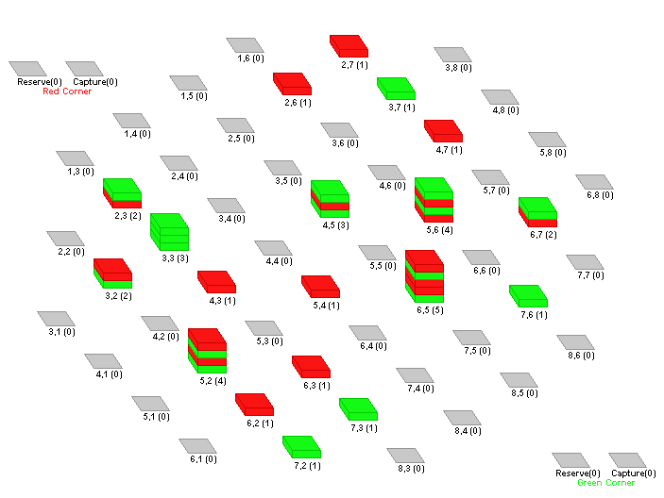

Figure 5: Board before the multiple moves are played to create the reserve and capture coins.

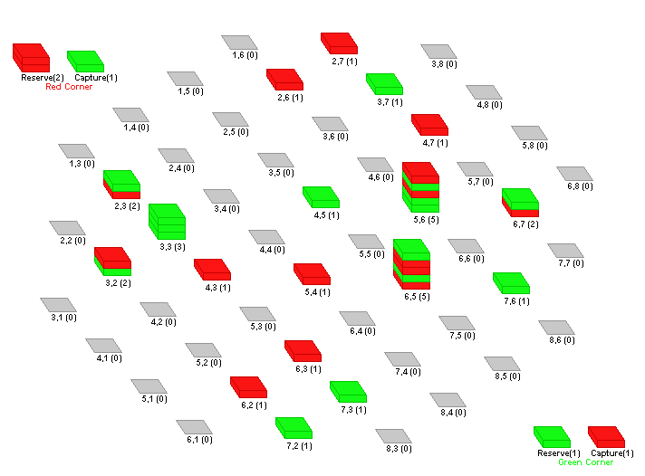

Figure 6: Board after the multiple moves are played to create the reserve and capture coins.
The reserve coins can be used by the player in his turn to place them anywhere (empty space, single coin stack or multiple coin stack) on the board instead of playing a multiple or single move. If placed on a stack, they are always placed on the top. In doing so if the number of coins in the stack exceeds 5 the additional coin is removed from the bottom of the stack just as stated previously in this problem statement. In each turn the player can only place a single coin and his turn is over. He cannot play any other move in this turn.
Additionally, to avoid a potential deadlock scenario in a game, a new rule as follows in being introduced.
- Any game that does not yield a result within 300 moves (150 each for the two players) will be declared as a draw and the points split between the players.

Evaluation:
Like the last two coder fest finals, this time also the winner will be decided by matches held between pairs of programs. The program that beats its opponents wins the contest and the team owning the program will be the “Champion Programmer of the year 2007”. The board shown in Figure 7 will be used to play the matches. (Individual teams are not required to create a board as part of their programs) The programs will be expected to communicate their moves to the board via an API. Further technical details on the APIs will be provided to the competing teams separately on or before 20th February, 2008.

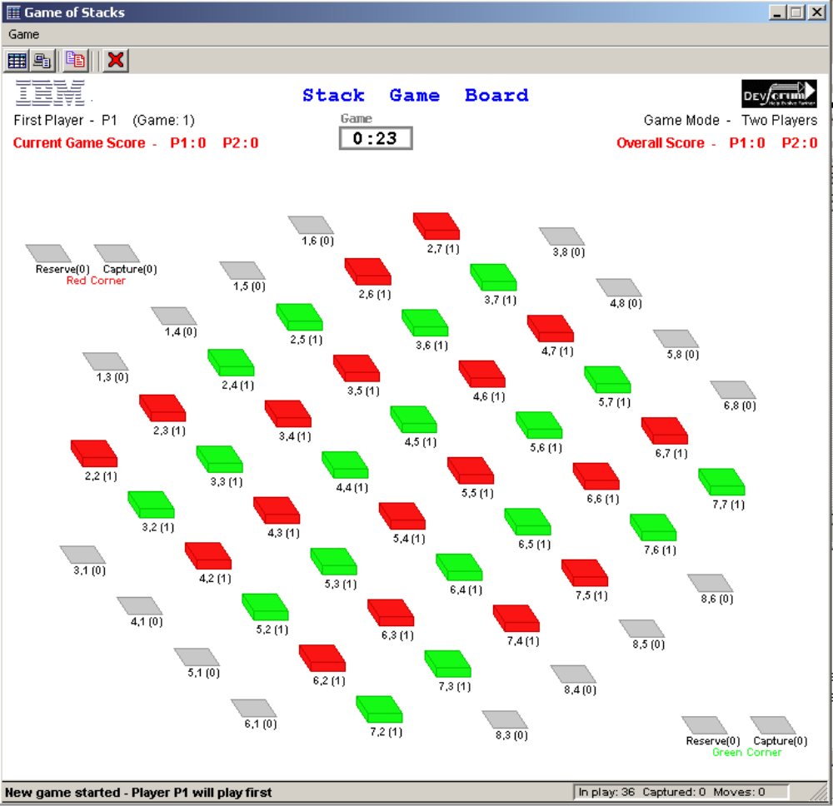

Figure 7: The board on which the programs will compete.

Good Luck and Happy Programming!
(Last date for submission of Solutions: 27th February, 2008 – 6PM IST)

